Cost-push inflation and world input-output tables

# Abstract

Understanding how exchange rate movements impact inflation is critically important for monetary policy.

Using several datasets covering most advanced and emerging economies, this column analyses which countries and sectors are under pressure to adjust their prices when subject to an exchange rate variation.

It documents the heterogeneous reactions of consumer prices to exchange rate variations across countries, reflecting differences in foreign product content of consumption and intermediate products.

# Introduction

With the rise of global value chains, numerous researchers have used world input-output tables (WIOTs) to shed light on international economics issues. Theses tables are important to measure the exposure to international risk (Borin, Mancini and Taglioni 2022), attributing carbon emissions across countries (Airebule, Cheng and Ishikawa 2022), looking into the beneficiary of trade-generated income (Bohn, Brakman and Dietzenbache 2021)…

As part of a research team at Banque de France, we have also been using WIOTs to analyze cost-push inflation. Specifically, we have studied the effect of sectoral price shocks and exchange rate movements. In doing so, we have unearthed regularities that should be of interest to all WIOTs users.

In this column, we start with a topical subject: vulnerability to hydrocarbon prices, especially Russian ones. We then move to the effect of exchange rate movement on inflation and show that extrapolation based on not-quite-current WIOTs leads to valid insights. Finally, we focus on which countries and sectors are under pressure to adjust their prices when subject to an exchange rate variation.

# Vulnerability to hydrocarbon prices

Following the Russian invasion of Ukraine, there has been many discussions on the effect of sanctions on Western economies. They are vulnerable to the effect of energy-price cost-push inflation. Germany is especially vulnerable to an increase in Russian natural gas prices that might lead to high inflation (Afunts, Cate, Helmschrott and Schmidt 2022). Looking at WIOTs does not replace in-depths studies with much more sophisticated behavioral hypotheses, but it gives a relatively easy way to compare each country vulnerability to these shocks using WIOD

Figure A : Vulnerability to hydrocarbon prices and Russian hydrocarbon price increases, WIOD

The results shows that…

One might be worried that this computation relies on not-quite-up-to-date WIOTs: the last version of WIOD was published in 2016 and gives data for 2014. (See Timmer et al. 2015 and Timmer et al. 2016) (<https://www.rug.nl/ggdc/valuechain/wiod/>). Moving to the study of the effect of exchange rate movements assuages these fears.

# Elasticity of consumer prices to exchange rate variations over two decades

Understanding how exchange rate movements impact inflation is critically important for monetary policy. The transmission of exchange rate movements to consumer prices differs across countries. It depends, among other things, on their respective trade openness, the relative integration of sectors and firms in international production chains and the currency of invoicing for trade. In a recent paper (Camatte et al., 2021), we analyze the impact of exchange rate variations on domestic consumer prices using several datasets covering most advanced and emerging economies, from 1995 to 2019.

What we find is likely an upper bound as our accounting approach relies on the simplifying assumption that exchange rate fluctuations completely pass-through to import prices.

However, a large body of literature suggests that the pass-through is incomplete, even in the long run, as a result of slow nominal price adjustments or the pricing-to-market behaviour of firms. Hence, using alternative assumptions would entail lower estimates. Still, our estimates are useful to compare the pure accounting vulnerability of different economies to an exchange rate shock.

In line with the existing literature, we find that in response to a 1% appreciation of the domestic currency, domestic consumer prices decrease by around 0.10% on average at the world level. The impact of exchange rate variations on consumer prices has remained broadly stable over the past two decades. We find that the mean output-weighted elasticity of consumer prices slightly increased from 2000 to 2008. After peaking in 2008, the elasticity sharply declined in 2009 and has hovered around 0.1 in subsequent years.

Interestingly, this result is robust to using two different WIOTs (TiVA from the OECD and WIOD) and even to extrapolating to the 2015-2019 period by using only trade data from BACI (imported consumption and intermediary goods) and GDP data. We also show the results for MRIO, an offshoot of WIOD, but we believe issues in the treatment of China and maybe India explain the increase of the elasticity in 2018 and 2019 in the version of the database we used.

Figure B Comparing the computed elasticity of domestic prices to exchange rate shocks to predictions based on World Bank and BACI data.

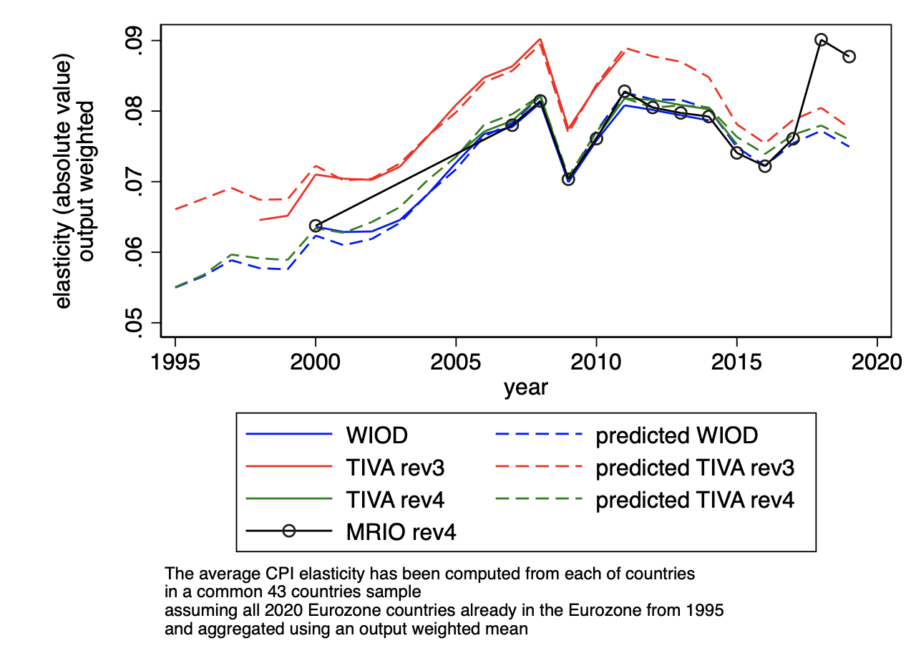

Sources: WIOD, TIVA, MRIO, World Bank, BACI and Camatte et al. (2021)

# Heterogeneity and channels of the effect of exchange rate variations on consumer prices

This gives confidence that Depending on the country, the impact of a 1% exchange rate fluctuation on domestic prices ranges from 0.05% to 0.22%, reflecting different degrees of openness to trade and differences in foreign product content in domestic consumption.The elasticity is lower for large advanced and developing countries. For instance, we find an elasticity of 0.06 for the US.

Within the euro area, the elasticity of domestic consumer prices differs substantially.

It ranges from 0.07 in Italy to 0.18 in Ireland, a small open economy with a large traded sector and a large share of trade outside the euro area. For larger countries (France, Germany, Italy and Spain) and countries whose trade is concentrated with euro area partners (such as Portugal and Greece), the elasticity is close to 0.10~~, reflecting a lower degree of openness to trade~~. The elasticity is twice higher for small open economies like Luxembourg, Malta, Slovakia and Ireland.

The value of the elasticity is closely, but not perfectly, related to the share of imported goods and services in household consumption. Overall, the higher a country’s import share in consumption, the higher the elasticity of domestic consumer prices to the exchange rate.

Figure C Elasticity of the HCE deflator to a shock in the domestic currency (**Le faire en extrapolé pour 2019)

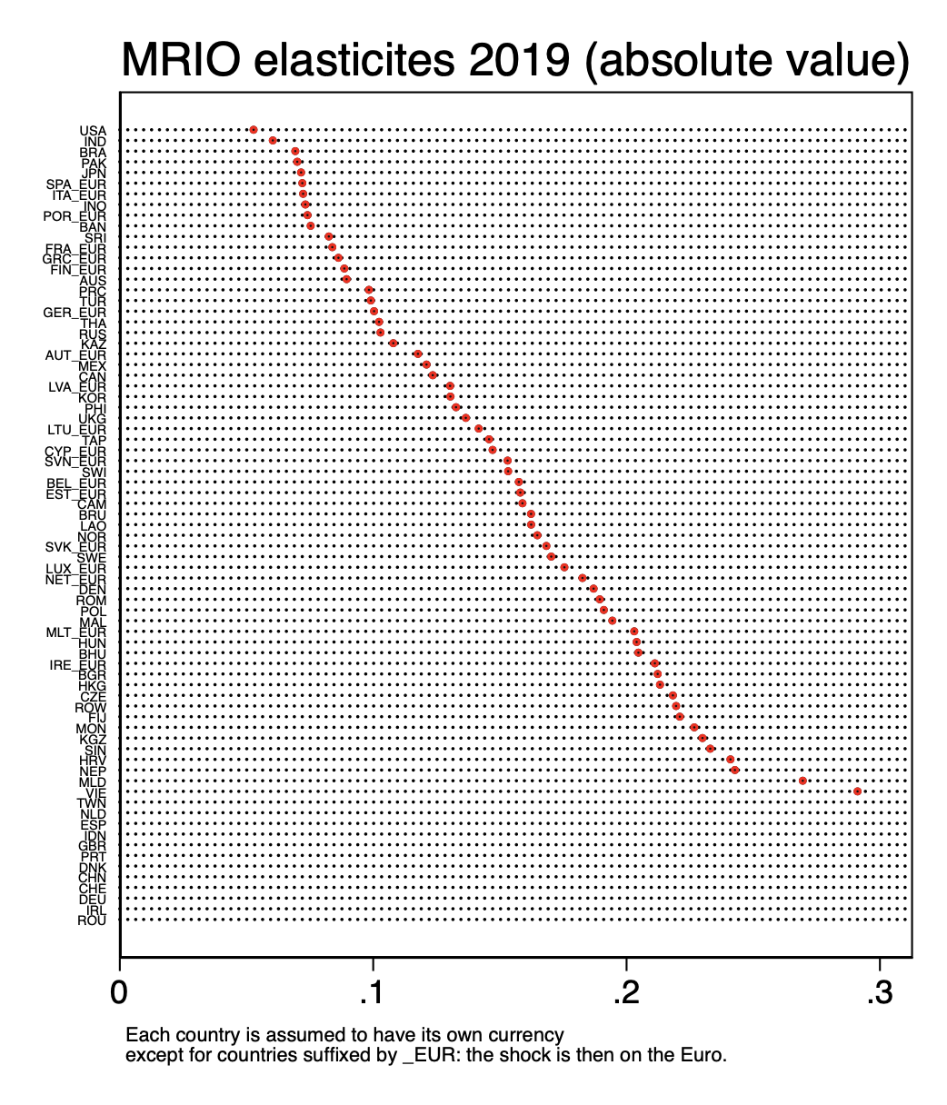

We also analyse the role of global value chains in the transmission of an exchange rate appreciation.We identify four channels through which an exchange rate appreciation impacts consumer prices when production processes are global:

i) the price of imported final goods sold directly to domestic consumers;

ii) the price of imported inputs entering domestic production;

iii) the price of exported inputs feeding through imported foreign production;

iv) changes in domestic and foreign production costs in turn pass through to the price of inputs for domestic and foreign goods, causing further production costs variations through input-output linkages.

We find that the first two channels explain three-quarters of the transmission of an exchange rate appreciation to domestic prices. The last two channels, which reflect the impact of participation in global value chains, play a limited role, with marked across-countries heterogeneity.

Figure D : Channels of the exchange rate shock effect on consumer prices (WIOD, 2014) -- ** À faire en couleur**

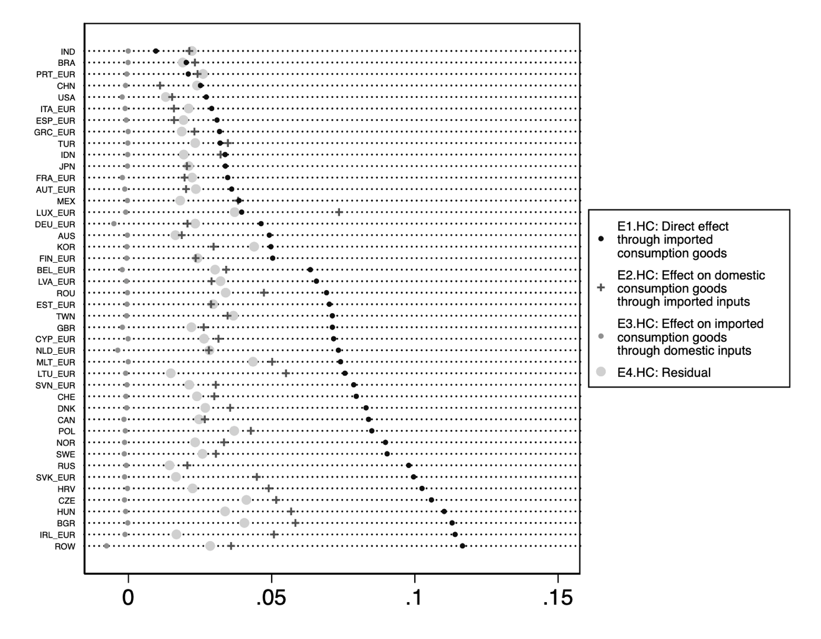

# Conclusion

# Bibliography

Airebule, P, H Cheng, J Ishikawa (2022), “Shared responsibility criterion for allocating carbon emissions across countries”, VoxEU.org, 28 February

Bohn, T, S Brakman and E Dietzenbacher (2021), “From gross exports to value-added exports to income exports”, VoxEU.org, 15 June (https://voxeu.org/article/gross-exports-value-added-exports-income-exports)

Borin, A, M Mancini and D Taglioni (2022), “Integration if global value chains might not increase exposure to risk after all”, VoxEU.org, 1 March (https://voxeu.org/article/integration-global-value-chains-might-not-increase-exposure-risk-after-all)

Dietzenbacher, E, B Los, R Stehrer, M Timmer and G. de Vries, G. J. (2013). “The Construction of World Input-Output Tables in the WIOD Project.” Economic Systems Research, 25(1):71–98.

Afunts, G, M Cato, S Helmschrott, T Schmidt (2022) “Russia’s invasion of Ukraine has led to higher inflation expectations of individuals in Germany”, VoxEU.org, 20 April

Boz, E, C Casas, G Georgiadis, G Gopinath, H Le Mezo, A Mehl, and T Nguyen (2020), “Patterns in invoicing currency in global trade”, VoxEU.org, 9 October.

Boz, E, G Gopinath and M Plagborg-Moller (2018), “Global trade and the dollar”, VoxEU.org, 11 February.

Camatte, H, G Daudin, V Faubert, A Lalliard and C Rifflart (2021), "Estimating the elasticity of consumer prices to the exchange rate: an accounting approach", ECB Working Paper No 2610 / October 2021.

Timmer, M, E Dietzenbacher, B Los, R Stehrer, and G J de Vries (2015), "An Illustrated User Guide to the World Input–Output Database: the Case of Global Automotive Production" , Review of International Economics., 23: 575–605

Timmer, M. P., Los, B., Stehrer, R., and de Vries, G. J. (2016), "An Anatomy of the Global Trade Slowdown based on the WIOD 2016 Release," Technical report.